OR IMMEDIATE RELEASE
Images available at www.celco.com
IBC STAND 7.F45
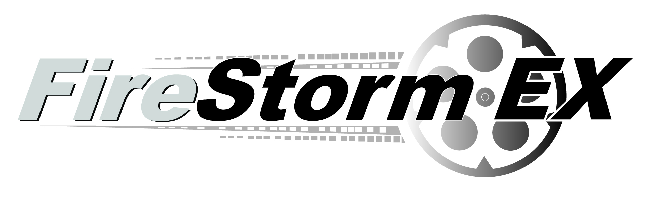
Celco Contact: John Constantine
+1.909.481.4648, john@celco.com

Celco Media Contact: Sharon Adcock
+1.310.545.9731, SkiAdcock@aol.com

CELCO INTRODUCES FireStorm EX DIGITAL
MOTION PICTURE RECORDER AT IBC 2009
Ultimate solution for low-cost, high-speed, high-resolution digital film transfers

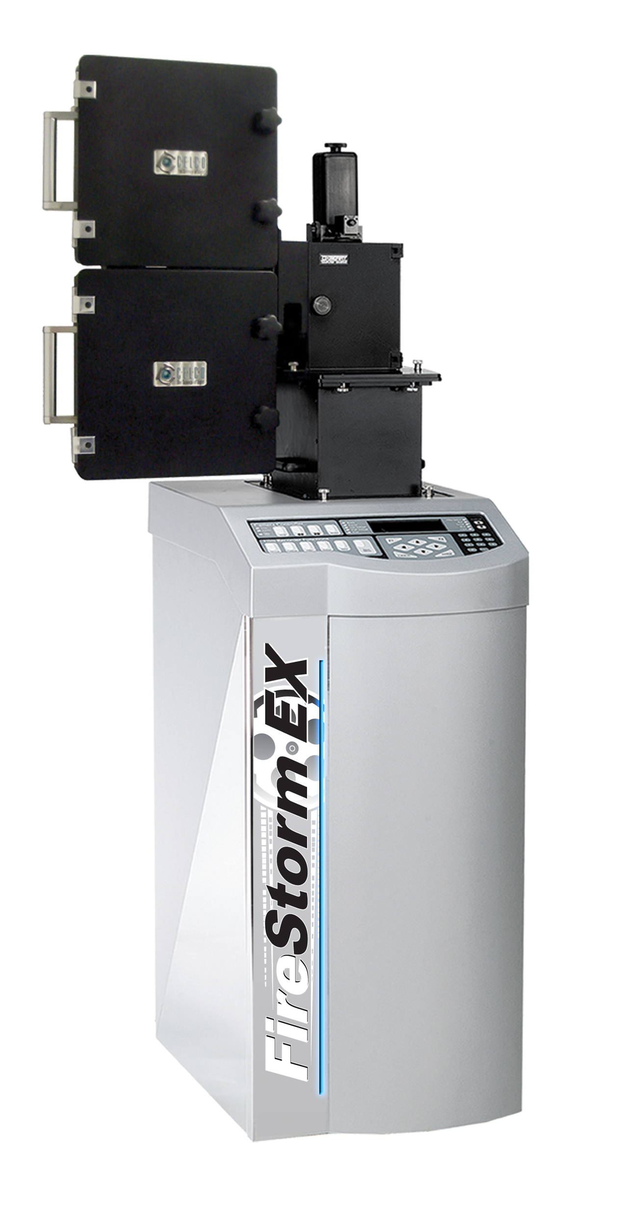
Rancho Cucamonga, CA, September 11, 2009…CELCO is introducing at IBC2009 the FireStorm EX, a new entry level Motion Picture Digital Film Recorder to complement the latest in its highly successful line of Firestorm Digital Motion Picture Recorders, and announced its immediate availability. The FireStorm EX is ideal for SD, HD, 2K, and 4K acquired productions, digital intermediates (DI), digital trailers, tape-to-film transfers, archive-to-film, and digital film restoration.

The new FireStorm EX offers top end Digital Intermediate image quality at an entry level price point, allowing startups or anyone who needs to add capacity to do so at low acquisition price without having to sacrifice image quality. The FireStorm EX offers CELCO’s no-compromise flexibility with capability to image to any film stock including fine grain intermediate, color camera negative, and black and white films at any resolution from SD to 4K.

In addition, CELCO has implemented its latest generation film imaging technology offering enhanced image sharpness and quality of the image output. The system is powered by CELCO’s new Linux host computer and film recorder driver software, making it easy to integrate into production workflows.

The very affordable FireStorm EX comes as a complete system which includes the film recorder, host computer, driver software and GUI.

The Firestorm EX has CELCO’s FilmOut Pro Advanced Film Recording Software. FilmOut Pro is an intuitive Graphical User Interface that controls the film recorder and includes imaging tools such as sharpening, degrain, image formatting, resizing and color management functions. A unique feature is the interactive A/B image comparison slider that allows the user to view images before and after different image processing tools have been applied. FilmOut Pro also includes FinalView, a viewing tool that displays the final image and its exact position on film.

John Constantine, Director of Marketing, states, “With today’s budgetary concerns and throughput requirements we realized there was a need for a low cost, entry level Motion Picture Digital Film Recorder that didn’t sacrifice image quality or capabilities. The new FireStorm EX is the perfect solution for emerging companies entering the Digital Intermediate arena as well as existing post productions facilities needing to increase capacity without large budgets. The new FireStorm EX offers affordability with pristine high resolution digital image transfers to film.”

CELCO manufactures the award-winning FURY and FireStorm line of Motion Picture Digital Film Recorders. These high-speed film recorders utilize CELCO’s XCRT Advanced Imaging Technology, resulting in unsurpassed image quality. CELCO film recorders are a core component of the digital intermediate process, which is increasingly being utilized in motion picture making. In 2002, CELCO received Scientific and Engineering Awards from the Academy of Motion Picture Arts and Sciences for the design and development of the CELCO Digital Film Recorder Products. The Academy cited CELCO film recorder products having a significant impact on the industry through continual improvements in their technology.

About CELCO:
CELCO was founded in 1950 by John M. Constantine Sr. as an engineering laboratory dedicated to high resolution display technology. CELCO’s innovations in the field of electron beam control soon made the company a leading producer of electron optics including deflection yokes and focus coils used in high resolution display systems. Its display components have been used for an abundance of military and civilian applications in everything from fighter jets, flight simulators, medical imaging systems, electron beam welders, to the space shuttle. CELCO also became known for its lab standard test equipment including high performance deflection amplifiers and precision display systems. The technologies evolved into the production of complete digital imaging systems starting in the 1970s with large format satellite imaging systems to the first motion picture digital film recorder used for Disney’s TRON in the early 1980s.
Clients have included Deluxe, Cinema Concepts, Disney Feature Animation, PIXAR, Industrial Light & Magic, Warner Bros., Tippett Studio, CFI/Technicolor, Double Negative, Post Logic Studios, Éclair Labs, AAV Digital Pictures, and Fotokem, just to name a few.
For further information, contact CELCO, 8660 Red Oak Ave., Rancho Cucamonga, CA, 91730, USA, tel +1.909.481.4648, fax +1.909.481.6899, info@celco.com, www.celco.com
###
All trademarks used herein, whether recognized or not, are the properties of their respective companies.

