
FOR IMMEDIATE RELEASE IBC STAND 7.441

CELCO Contact: John Constantine
+1.909.481.4648, john@celco.com

Media Contact: Sharon Adcock
+1.310.545.9731, skiadcock@aol.com

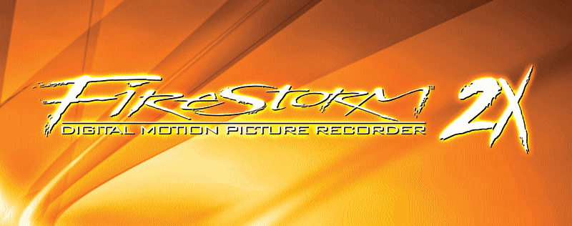
• Images available at www.celco.com

CELCO INTRODUCES FIRESTORM 2X INTERNATIONALLY
New enhanced performance digital film recorder features
more power, more speed and low cost

September 7, 2006…IBC Stand 7.441...CELCO (www.celco.com), Rancho Cucamonga,
CA, the leader in digital film recording systems, today introduced to the international community the newest version digital film recorder in its product line, the Firestorm 2X. Its predecessor, the Firestorm 2, was launched internationally at IBC 2005; since that time, several Firestorm 2 film recorders have been sold worldwide, indicating its rapid acceptance in the post-production community.

Announced at NAB 2006, the new Firestorm 2X is now shipping with the first installations in India, Taiwan and South America.

The Firestorm 2X will output a high-resolution frame of film in 1.4 seconds, which is twice as fast as the original Firestorm, and incorporates CELCO’s FilmOut Pro Advanced Digital Film Recording Software. FilmOut Pro is CELCO’s Film Recorder and Image Control Software for its latest generation FURY and Firestorm high performance digital motion picture film recorders.

The Firestorm 2X is a low cost, high-speed film recorder that utilizes CELCO's new XCRT
Advanced Imaging Technology, resulting in unsurpassed image quality. The new system
is a continuation of CELCO's advancement of their proven, award-winning electron beam control technology for transferring digital images to motion picture film.
The Firestorm 2X’s 1.4 second per frame speed includes high definition images onto Kodak
5201 or 5245 camera negative stock. The system is also capable of imaging to intermediate stock (Kodak 2242) and high-speed output of any resolution up to 4K or higher for larger format purposes such as 65mm. It takes only 12 seconds per frame to output a 4K 15-perf IMAX frame onto Kodak 5201 low ASA camera negative stock. The Firestorm can output multiple film stocks, including color and black and white intermediate and camera negative stocks. The new system can also output to multiple film formats including 16mm, 35mm, and 65mm 5, 8, 10, and 15-perf (IMAX format). The system will also have the option to add CELCO’s newly developed 2000ft split film magazines.

FilmOut Pro’s intuitive Graphical User Interface (GUI) controls the film recorder and includes a variety of image processing and viewing tools in a user friendly, easy to understand environment. FilmOut Pro will allow the operator to define aspect ratios and formats, and will provide image cropping, offset, and resizing tools. It will display image histograms by color channel and have selectable image sharpening algorithms and degrain functions. FilmOut Pro also includes an automated color management tool to give Filmmakers on film what they see in the digital color-timing suite. A unique feature of FilmOut Pro is an interactive A/B image comparison slider that allows the user to view images before and after different image processing tools have been applied. Bundled within the FilmOut Pro software is FinalView, an image-viewing tool that displays the final image and its exact size and position on film. This gives the operator a final view of the image on film to verify everything is correct before the image is sent to the recorder.
John Constantine, Director of Marketing, states, "There are many facilities worldwide that
require both speed and quality yet don't have the budget for our FURY film recorder and
don't want to compromise with film recorders of lesser quality and performance from other
manufacturers. These facilities also want the peace of mind knowing that they’re investing
in technology provided by a well-established company who will continually improve its digital film recording products far into the future. CELCO has been providing digital film recording technology to this market for many years, and we're continually advancing the technology to meet the rigorous demands required by post-production facilities around the globe. We're experts in this field, not newcomers, and we provide unparalleled support and service, which is why facilities continually invest in our digital film recorders to meet their imaging needs."

About CELCO:

CELCO was founded in 1950 by John M. Constantine Sr. as an engineering laboratory dedicated to high resolution display technology. CELCO’s innovations in the field of electron beam control soon made the company a leading producer of electron optics including deflection yokes and focus coils used in high resolution display systems. Its display components have been used for an abundance of military and civilian applications in everything from fighter jets, flight simulators, medical imaging systems, electron beam welders, to the space shuttle. CELCO also became known for its lab standard test equipment including high performance deflection amplifiers and precision display systems. The technologies evolved into the production of complete digital imaging systems starting in the 1970s with large format satellite imaging systems to the first motion picture digital film recorder used for Disney’s TRON in the early 1980s.

Clients have included CFI/Technicolor, Post Logic Studios, Rainmaker, Cinema Concepts, Disney Feature Animation, PIXAR, Industrial Light & Magic, Warner Bros., Tippett Studio, Double Negative, Éclair Labs, AAV Digital Pictures, Taipei Motion Picture Co., Oriental Post, just to name a few.

For further information, contact CELCO, 8660 Red Oak Ave., Rancho Cucamonga, CA, 91730, USA, tel +1.909.481.4648, fax +1.909.481.6899, info@celco.com, www.celco.com

###

All trademarks used herein, whether recognized or not, are the properties of their respective companies.

